MySQL Assignment1- DDL Commands- Exceution Screenshots

Database and Table Creation (CREATE):
Drop database if Exists Employee;

Create database Employee; Use Employee;

Create Table Departments( Department_Id int Primary key,
Department_Name Varchar(30) unique not null);

Create Table Location(
Location_Id int Primary Key auto_increment, Location_Name Varchar(50) unique not null);

Create table Employees( Employee_Id int Primary Key,
Employee_Name varchar(50) Unique Not Null, Gender ENUM("M","F"),
Age int check(Age>=18),
Hire_Date date default(current_date()), Designation varchar(30),
Salary int, Department_Id int, Location_Id int,
constraint fk_Department_Id foreign key(Department_ID) references Departments(Department_ID),
constraint fk_Location_Id foreign key(Location_ID) references Location(Location_Id));

- Table Alteration (ALTER)

Alter table Employees add Email varchar(50);
Alter table Employees modify Column Designation varchar(100); Alter table Employees Drop Column Age;
Alter table Employees Rename Column Hire_Date to Date_Of_Joining;

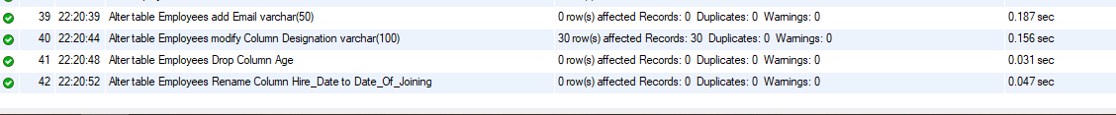

- Table Renaming (RENAME):

Rename table Departments to Departments_Info; Rename table Location to Locations;

- Table Truncation (TRUNCATE):
- Database & Table Dropping (DROP):
Truncate table Employees;
Drop table Employees;
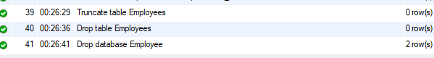
Drop database Employee;

